**DAILY ONLINE ACTIVITIES SUMMARY**

|  |  |  |  |  |  |  |  |  |
| --- | --- | --- | --- | --- | --- | --- | --- | --- |
| **Date:** | **03-06-2020** | | | | | **Name:** | **Nihal Rafiq** | |
| **Sem & Sec** | **4th A** | | | | | **USN:** | **4AL18CS052** | |
| **Online Test Summary** | | | | | | | | |
| **Subject** | | **Object Oriented Concept** | | | | | | |
| **Max. Marks** | | **30** | | **Score** | | | **09** | |
| **Certification Course Summary** | | | | | | | | |
| **Course** | **1. Introduction to Data Studio** | | | | | | | |
| **Certificate Provider** | | | **Great Learning Academy** | | **Duration** | | | **2.5 hours** |
| **Coding Challenges** | | | | | | | | |
| **Problem Statement:**  **1. Write a code segment in java to swap two numbers using call by object reference.**  **2. Write a java program to find last digit of a^b for large numbers.** | | | | | | | | |
| **Status: Executed** | | | | | | | | |
| **Uploaded the report in Github** | | | | | **Yes** | | | |
| **If yes Repository name** | | | | | **https://github.com/nihal-art/lockdown-coding** | | | |
| **Uploaded the report in slack** | | | | | **Yes** | | | |

Online Test Details:

The today’s online test was from module 2 and 3 of OOC (18CS45). The duration of the test was 45 min from 09:15am to 10:00am. The questions were based on the programs. Score I received is 09/30

Certification Course Details:

Introduction to Data Studio:

In today’s certification I’ve completed the modules which contains Connect data, creating a new report and adding charts, adding and configuration of report controls, share reports, data visualization basics, create and use report templates. And completed with 2 assessment test.

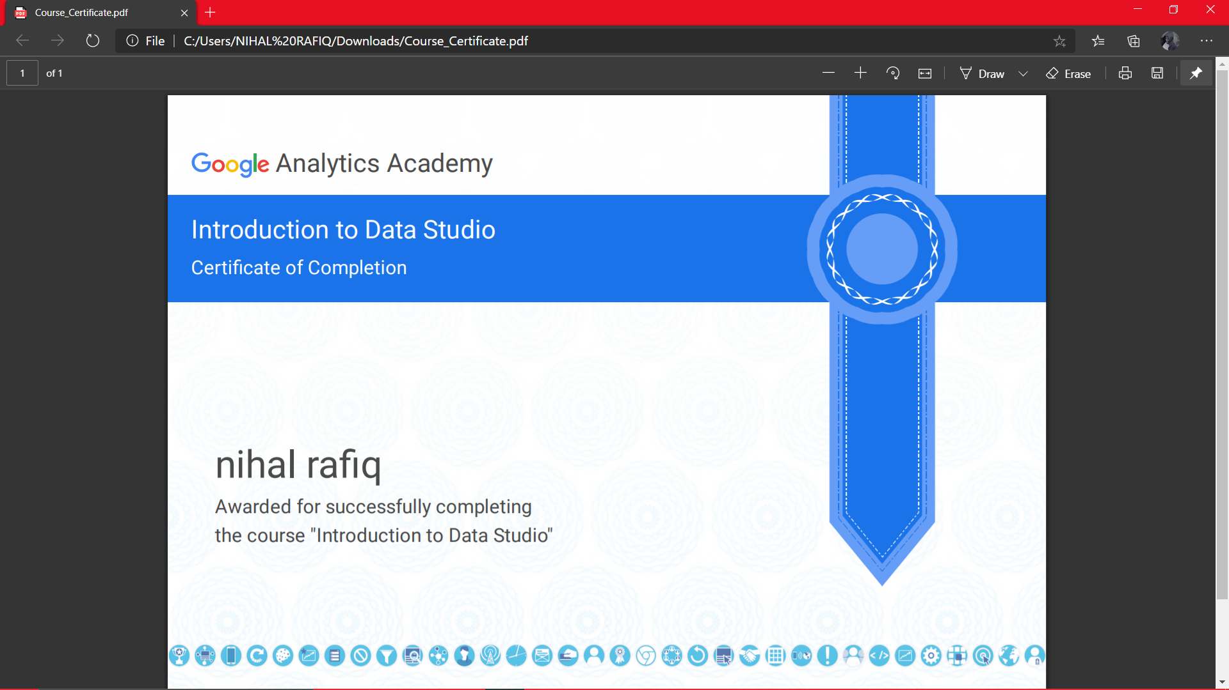

Coding Challenges Details:

**1.** Write a code segment in java to swap two numbers using call by object reference

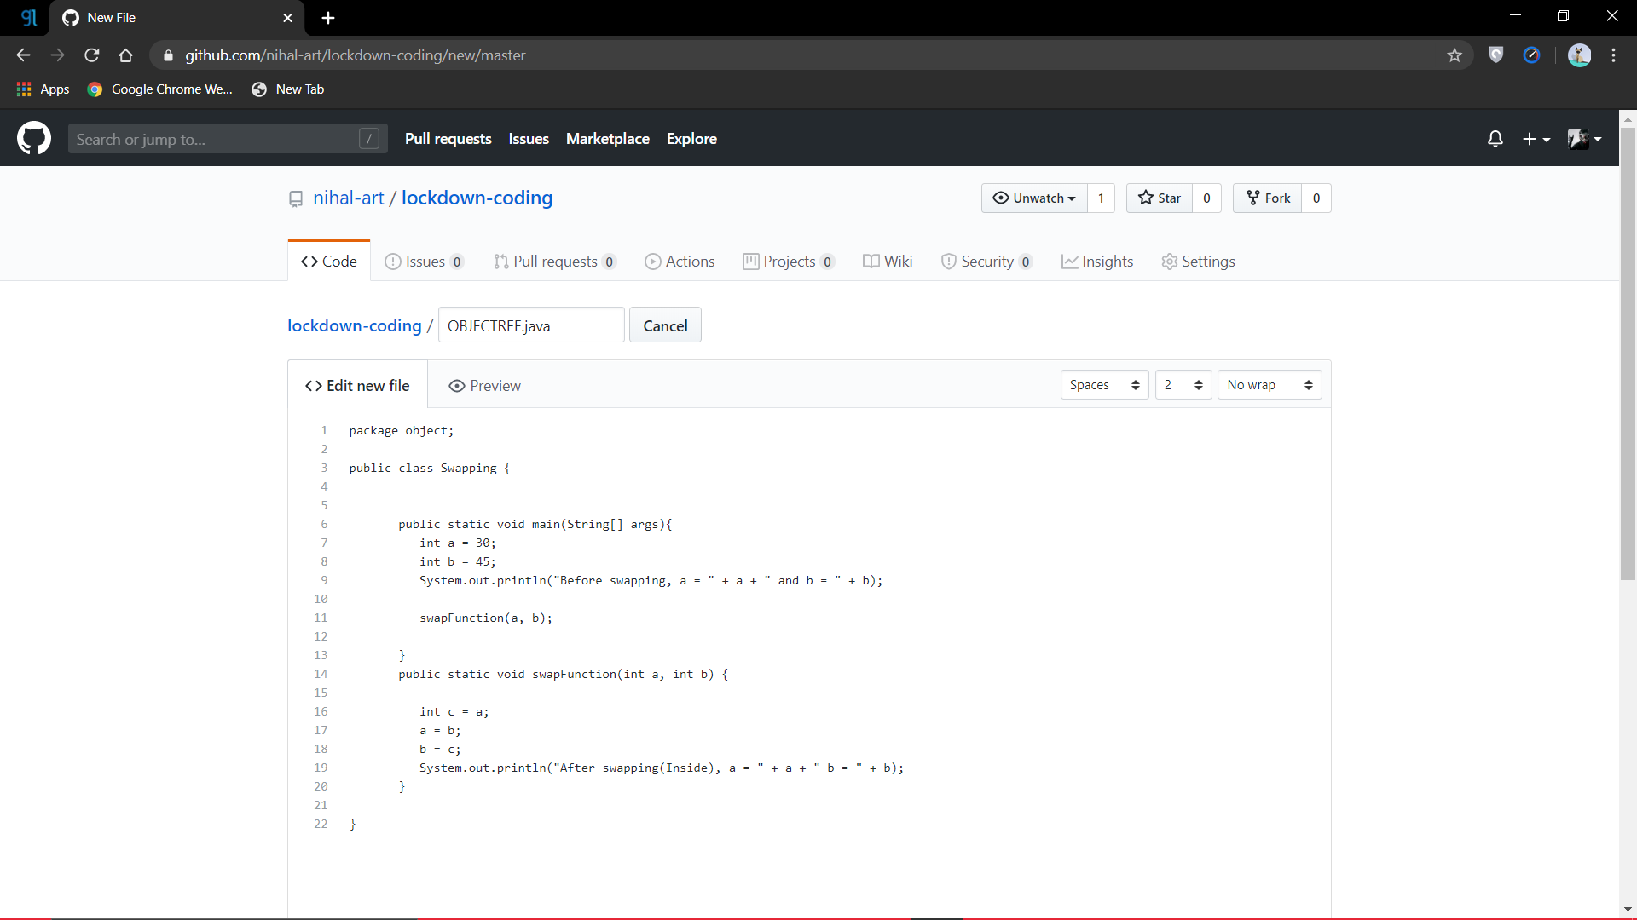

**2.** Write a java program to find last digit of a^b for large numbers.

You are given two integer numbers, the base a and the index b. You have to find the last digit of a^b.

Input: 3 10

Output: 9

